SIMULATION EXPERIMENT – 1

- Simulation-Based Electromagnetic Analysis of TEM, TE and TM Propagation Modes in Microwave Transmission Structures
CO Mapping: CO1
Bloom's Level: K4 – Analyze
WK Level: WK3 – Fundamental propagation modes
Objectives of this Experiment:
- To develop electromagnetic simulation models for TEM, TE and TM propagation modes in suitable microwave transmission structures.
- To visualize and analyze the electric-field and magnetic-field distributions associated with different propagation modes.
- To determine the cutoff frequency, propagation constant and field characteristics of selected TE and TM modes.
- To compare the propagation behavior of different modes and identify their suitability for practical microwave transmission.

Software Required: MATLAB / CST Studio Suite / Ansys HFSS / COMSOL
- Objective linkage: Develop TEM/TE/TM models, visualize E/H fields, determine cutoff frequency and propagation constant, and compare propagation behaviour.
Experimental Procedure:
A. TE10 Mode Simulation: A WR-90 rectangular waveguide has a = 22.86 mm, b = 10.16 mm and length L = 100 mm. Operate it at f = 10 GHz and excite the dominant TE10 mode in HFSS. Obtain the E-field and H-field distributions, simulated cutoff frequency fc and propagation constant β. Calculate fc (theory) = c/(2a), β = (2πf/c)√[1−(fc/f)²], and the percentage deviation of simulated fc from theoretical fc.
B. TE10 versus TM11: Using the same WR-90 waveguide at f = 10 GHz, simulates both TE10 and TM11 modes. Determine fc, β and the E/H-field distributions for each mode. Calculate the theoretical cutoff frequencies using fc(mn)=c/2√[(m/a)²+(n/b)²]. Compare the results and justify why TE10 propagates at 10 GHz while TM11 does not.

- INPUT PARAMETER TABLE – VALUES TO BE ENTERED
S.No | Input Parameter | Symbol / Setting | Value to Enter | Unit
1 | Operating frequency | f | 10 | GHz
2 | Waveguide width | a | 22.86 | mm
3 | Waveguide height | b | 10.16 | mm
4 | Waveguide length | L | 100 | mm
5 | Modes | — | TE10 and TM11 | —

- FORMULA TO BE USED:
• Waveguide cutoff frequency: fc(mn) = (c/2)√[(m/a)² + (n/b)²].
• For TE10 mode in a rectangular waveguide: fc10 = c/(2a).
• Above cutoff, propagation constant: β = k0√[1 − (fc/f)²], where k0 = 2πf/c.
• Percentage deviation = |Practical − Theoretical| / |Theoretical| × 100.
• TEM mode has no cutoff frequency in an ideal TEM transmission line; TE/TM modes have cutoff.

Key Conditions & Threshold Values for Analysis

1. Operating Frequency Range
- Frequency sweep: Typically 8–15 GHz for WR‑90.
- Threshold condition:
  - Mode propagates only if f > fc.
  - If f<fc, fields decay exponentially (evanescent mode).

3. Cutoff Frequency (fc)
- Formula for TE/TM modes:
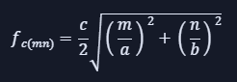
- Threshold value:
  - TE10 cutoff ≈ 6.56 GHz (for WR‑90).
  - TM11 cutoff ≈ 16.42 GHz.
- Condition:
  - TE10 propagates at 10 GHz (since f > fc).
  - TM11 does not propagate at 10 GHz (since f < fc).

4. Propagation Constant (β)
- Formula:
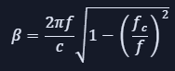
- Threshold condition:
  - β must be real for propagation.
  - If β becomes imaginary → evanescent mode.
- Analysis: Compare simulated β with theoretical values. Acceptable deviation ≤ 5%.

5. Field Distribution (E/H Fields)
- Condition:
  - TE10 → One half‑cycle variation of E‑field across width a.
  - TM11 → Two variations across a and one across b.
- Threshold check:
  - Correct symmetry and nodal lines must appear in simulation.
  - Any distortion indicates wrong excitation or boundary setup.

6. Deviation Limits
- Cutoff frequency deviation: ≤ 5% from theory.
- Propagation constant deviation: ≤ 5%.
- Field distribution: Qualitative match with theoretical mode patterns.

7. The conditions and thresholds you analyze are:
- Geometry correctness
- Frequency vs. cutoff frequency relation
- Real vs. imaginary propagation constant
- Field distribution symmetry/nodal structure
- Numerical deviation limits (≤ 5%)
Matlab Code
clc;
clear;
close all;
a = 22.86; % Width in mm
b = 10.16; % Height in mm
L = 100; % Length in mm
f = 10; % Operating frequency in GHz
c = 3e8; % Speed of light in m/s
am = a*1e-3;
bm = b*1e-3;
Lm = L*1e-3;
fm = f*1e9;
fc_TEM = 0; % TEM only in a two-conductor structure
fc_TE10 = c/(2*am)/1e9;
fc_TE20 = c/am/1e9;
fc_TE01 = c/(2*bm)/1e9;
fc_TM11 = (c/2)*sqrt((1/am)^2+(1/bm)^2)/1e9;
beta_TE10 = 2*pi*fm/c*sqrt(1-(fc_TE10/f)^2);
if f > fc_TM11
beta_TM11 = 2*pi*fm/c*sqrt(1-(fc_TM11/f)^2);
else
beta_TM11 = NaN; % Evanescent mode below cutoff
end
x = linspace(0,a,60);
y = linspace(0,b,40);
[X,Y] = meshgrid(x,y);
TEM = ones(size(X));
TE10 = sin(pi*X/a);
TM11 = sin(pi*X/a).*sin(pi*Y/b);
Ey = TE10;
Hx = (fc_TE10/f)*TE10;
Hz = cos(pi*X/a);
figure('Color','k','Name','WR-90 Waveguide Mode Analysis');
subplot(3,3,1);
surf(X,Y,TEM);
shading interp;
title('TEM Pattern','Color','w');
xlabel('x (mm)'); ylabel('y (mm)'); zlabel('Amplitude');
axis tight; view(35,25);
subplot(3,3,2);
surf(X,Y,TE10);
shading interp;
title('TE10 Pattern','Color','w');
xlabel('x (mm)'); ylabel('y (mm)'); zlabel('Amplitude');
axis tight; view(35,25);
subplot(3,3,3);
surf(X,Y,TM11);
shading interp;
title('TM11 Pattern','Color','w');
xlabel('x (mm)'); ylabel('y (mm)'); zlabel('Amplitude');
axis tight; view(35,25);
subplot(3,3,4);
surf(X,Y,Ey);
shading interp; colorbar;
title('Electric Field Ey','Color','w');
xlabel('x (mm)'); ylabel('y (mm)');
zlabel('Normalized Ey');
axis tight; view(35,25);subplot(3,3,5);
surf(X,Y,Hx);
shading interp; colorbar;
title('Magnetic Field Hx','Color','w');
xlabel('x (mm)'); ylabel('y (mm)');
zlabel('Normalized Hx');
axis tight; view(35,25);
subplot(3,3,6);
surf(X,Y,Hz);
shading interp; colorbar;
title('Magnetic Field Hz','Color','w');
xlabel('x (mm)'); ylabel('y (mm)');
zlabel('Normalized Hz');
axis tight; view(35,25);subplot(3,3,7);
fc_values = [fc_TEM fc_TE10 fc_TE20 fc_TE01 fc_TM11];
bar(fc_values);
set(gca,'XTickLabel',{'TEM','TE10','TE20','TE01','TM11'});
ylabel('Frequency (GHz)');
title('Cutoff Frequency Comparison','Color','w');
grid on;
subplot(3,3,8);
bar(fc_values);
hold on;
plot(1:5,f*ones(1,5),'r--','LineWidth',1.5);
set(gca,'XTickLabel',{'TEM','TE10','TE20','TE01','TM11'});
ylabel('Frequency (GHz)');
title('Mode Comparison','Color','w');
legend('Cutoff Frequency','Operating Frequency');
grid on;
subplot(3,3,9);
beta_values = NaN(1,5);
beta_values(2) = beta_TE10;
mode_fc = [fc_TEM fc_TE10 fc_TE20 fc_TE01 fc_TM11];
for k = 1:5
if f > mode_fc(k) && k ~= 1
beta_values(k) = 2*pi*fm/c*sqrt(1-(mode_fc(k)/f)^2);
end
end
beta_values(1) = 2*pi*fm/c; % TEM free-space reference
bar(beta_values);
set(gca,'XTickLabel',{'TEM','TE10','TE20','TE01','TM11'});
ylabel('Propagation Constant (rad/m)');
title('Propagation Constant Comparison','Color','w');
grid on;
sgtitle('WR-90 Waveguide: TEM, TE and TM Mode Analysis', ...
'Color','w','FontWeight','bold');
fprintf('\nWR-90 WAVEGUIDE ANALYSIS\n');
fprintf('Operating frequency = %.2f GHz\n',f);
fprintf('Waveguide dimensions = %.2f x %.2f mm\n',a,b);
fprintf('Waveguide length = %.2f mm\n',L);
fprintf('\nCutoff frequencies:\n');
fprintf('TE10 = %.5f GHz\n',fc_TE10);
fprintf('TE20 = %.5f GHz\n',fc_TE20);
fprintf('TE01 = %.5f GHz\n',fc_TE01);
fprintf('TM11 = %.5f GHz\n',fc_TM11);
fprintf('\nTE10 propagation constant = %.4f rad/m\n',beta_TE10);
fprintf('TE10 phase shift = %.4f rad\n',beta_TE10*Lm);
fprintf('\nPropagation at %.2f GHz:\n',f);
fprintf('TE10: Propagating\n');
fprintf('TM11: Below cutoff; evanescent\n');
fprintf('TEM: Requires a two-conductor structure\n');
fc_simulated = fc_TE10; % Replace with actual HFSS result
deviation = abs(fc_simulated-fc_TE10)/fc_TE10*100;
fprintf('TE10 cutoff frequency deviation = %.2f %%\n',deviation);

Output Results
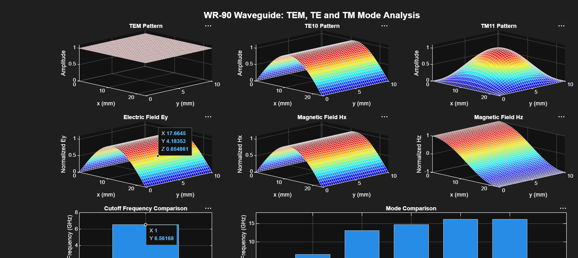

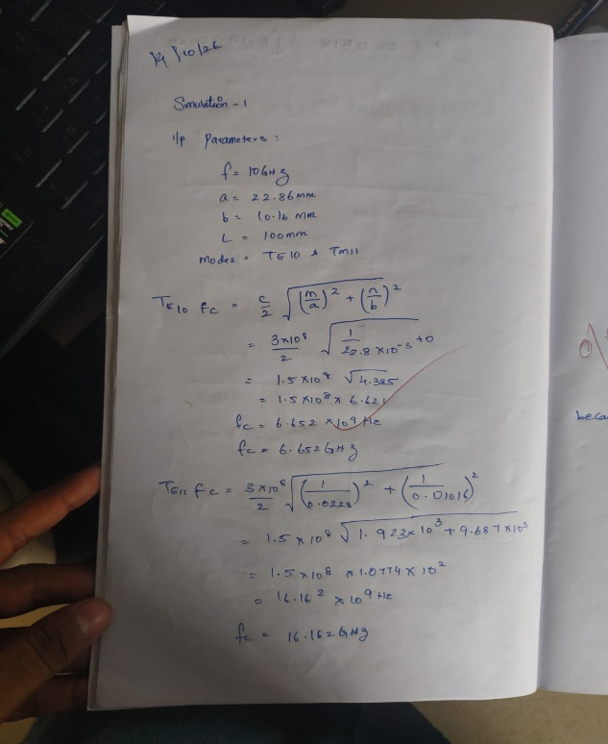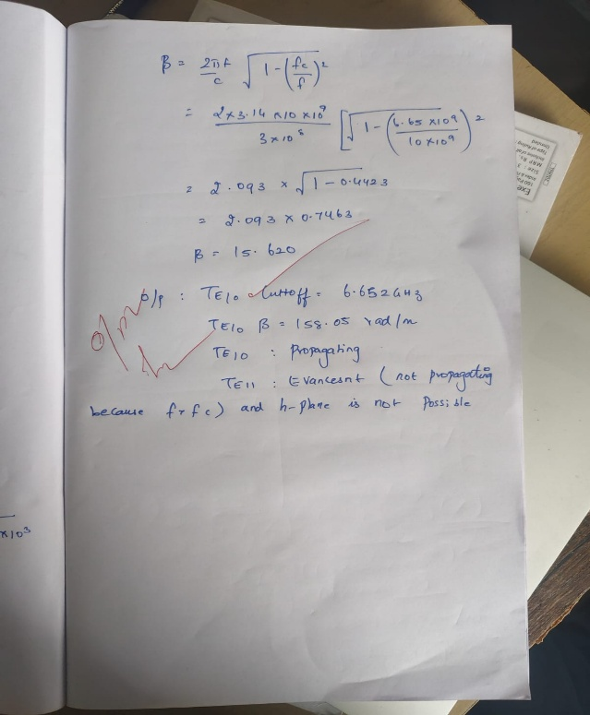
OUTPUT PARAMETER TABLE – VALUES TO BE RECORDED
S.No. | Output Parameter | Theoretical / Expected Value | Practical / Simulated Value | % Deviation
1 | E-field distribution | TE10/TM11 field pattern | TE10 and TM11 field plots observed | —
2 | H-field distribution | TE10/TM11 field pattern | TE10 and TM11 field plots observed | —
3 | Cutoff frequency | TE10 = 6.557 GHz; TM11 ≈ 16.42 GHz | TE₁10= 6.557 GHz; TM11 = 16.42 GHz
4 | Propagation constant | TE10 ≈ 198.9 rad/m at 10 GHz | 198.9 rad/m
5 | Mode decision | TE10 propagates; TM11 is below cutoff | Record observation | —

